**B.E. PROJECT (2011-2012)**

**ON**

**AUTONOMOUS**

**ROBO SUMOS**

**TEAM (5) MEMBERS:-**

**UMESH NAIR**

**VINOD SALUNKE**

**SREERAM KRISHNAN**

**TABLE OF CONTENTS:-**

|  |  |  |
| --- | --- | --- |
| **Sr. No.** | **Topic** | **Page No.** |
| 1 | Introduction | 3 |
| 2 | Literature Reviewed | 4 |
| 3 | Problem Statement | 6 |
| 4 | Requirement Analysis | 7 |
| 5 | Project Design | 10 |
| 6 | Implementation Details | 13 |
| 7 | Technologies Used | 18 |
| 8 | Test Cases | 22 |
| 9 | Timeline Chart | 24 |
| 10 | Task Distribution | 25 |
| 11 | Conclusion | 26 |
| 12 | Future Work | 27 |
| 13 | References | 28 |

1. **INTRODUCTION:-**

Our project is dedicated to all robotics application lovers. The project is inspired by the exceptional attribute of current robos and it’s way of communicating with the external environment.

Mini-sumo is a competition between robots based on Japanese wrestling –“Sumo” is the Japanese word for wrestling. Similar to traditional sumo matches, two opponents (robots) face each other in a ring named a ‘dohyo’.

Mini-sumo robots are small autonomous mobile robots designed specifically for sumo style competition.The application is user friendly and can be run found on any computers with Zigbee and robo connections.

Mini-sumo robots are small autonomous mobile robots designed specifically for sumo style competition.

This project is developed using open-source softwares, and so made on a low budget. The concept of same traditional robo sumo is used to implement it. There will be three rounds as such and the winner of the competition will be declared based on this three rounds.

The robots are provided by the company called Nex Robotics. The name of the robot is Spark V robot which has basic components like microcontroller, motors, memory in kilobytes, LCD screen, sensors such as white-line, infrared, distance, etc.

The robot provides facilities for wireless communication by providing the features of using ZigBee module with it. ZigBee is basically used to transmit the data to the controller wirelessly. It has better features than Bluetooth protocol.

This project can also be implemented using IR sensors and white-line sensor which will help it to locate its position and also the opponents’ position.

This project can be used in the field for entertainment, security, patrolling and also for cleaning. The various strategies used in it makes the project an interesting one and also it can be an application were it can be used in the upcoming research in the field of agriculture where it can used for seed ploughing.

1. **LITERATURE REVIEWED:-**

**AHRC Mini Sumo Robot Contest:-**

**OBJECTIVES:**

* Encourage on-going interest in building robots with an annual showcase event.
* Encourage design of autonomous robots
* Encourage participation of all age groups in design competitions.
* Allow maximum number of entrants (from inside and outside of the club).
* Generate excitement from participants and audience during the competition.
* Have Fun!

**RULES SUMMARY:**

**Mini-Sumo Match:** Two robots compete one-on-one in a best two of three rounds match. The winner either pushes the opponent out of the ring or the opponent leaves the ring on its own. Each round has a 3-minute time limit with a mandatory five-second start delay.

**Robot Specification:** Robot must weight under 500 gm and not exceed 10 cm x 10 cm. In size. There is no height restriction. The robots must be autonomous. Radio Control is not allowed.

**Competition Ring**: Robots compete on a 77 cm diameter ring with flat black surface and a 2.5cm white rim.

**Qualification**: All competing robots must be able to push a wood block, 250 grams in weight, off the ring 2 out of 3 attempts. Qualifications will be performed at the contest prior to competition with the oversight of the Judge (Gioji) or an assigned witness. Robots may be quarantined after qualification until the scheduled competition.

**Contest Format:** Robots will compete in a series of one-on-one elimination matches until the top robot is the winner. Robots will be assigned to the first round of competitions based on a random draw prior to the contest. Some robots may be awarded a BUY during the elimination as a part of the assignment process. Each match consists of three rounds.

**Disallowed:** Jamming devices; parts that could inflict damage to the Ring or to the other robot; devices that can store and throw objects, liquid, powder, or air, at the opponent; flammable devices; and devices that adhere a robot to the Ring are not allowed.

**Conduct:** Sumo wresting is an honorable competition. The two teams bow in the Outer Ring at the beginning and end of each round. Actions that disgrace the fairness or honor of the match may be penalized at the discretion of the contest Judge (Gioji).

**CONTEST AWARDS:**

Prizes will be awarded for First, Second and Third Place winners.

Planned prize awards will be posted on the [www.botlanta.org](http://www.botlanta.org/) web pages.

**SPECIAL AWARDS:**

Entries to the Mini Sumo Competition are eligible for the AHRC Robot Rally© 2002 Special Awards. Achievements in robot building will be recognized with awards for the Coolest Bot, Most Original and Technical Innovation. The judging committee will make selection of the awards with consideration given to the age of the robot builder.

**ELIGIBILITY:**

There are no requirements. We encourage all hobby robot builders to enter. All entries will be judged according to the rules of the contest. Groups or teams are allowed to enter as a single entry.[1]

1. **PROBLEM STATEMENT:-**

The idea in our project is that there will be a square arena or board with a circular shape drawn inside of that square part .The area left between the square and circular will be having a different color than the part inside the circular shape.

There will be two robots inside the circular part and each robot will be trying to push the other robot outside the circular shape. There will be a camera mounted on top of the square arena which will be exactly be perpendicular to the surface .

This camera will be keeping a watch on the movement of two robots and will be passing required information to it.

The implementation will be done using programming languages like MATLAB/C which are the languages which are well understood by the microcontroller of the robot.

The wireless transmission between robo and the laptop/desktop using Zigbee module.It is a module that helps to transfer the data serially to any system wirelessly.

There will two zigbee modules which will transmit and receive the data.

The application is user friendly and can be run found on any computers with Zigbee and robot connections.

The concept of image processing is used for capturing the images from the camera.The image will be continuously taken by the camera and using the code written in the controller for image processing will be used which will edited or converted in the format as per requirement .

This converted image will be transmitted to robot using the ZigBee module.

The two robot will use Image processing for locating the other robot i:e opponent and also to locate it’s own position and will try to push the opponent out of the ring and also prevent itself from going outside the ring.

The no of images captured by camera and processed by the robot will depend upon the processing speed of the robot’s microcontroller.

The unit of the speed will be in gigahertz hence the more the speed will help for robot to fastly locate it robot’s position.

1. **REQUIREMENT ANALYSIS:-**

Requirement analysis in a system engineering and software engineering, encompasses those tasks that go into determining the needs or conditions to meet a new or altered product, taking account of possibly conflicting requirements of various stakeholders, such as beneficiaries or users.

Conceptually, requirements analysis includes three types of activities:-

* 1. Requirement elicitation
  2. Requirement analysis
  3. Requirement recording
  4. **REQUIREMENT ELICITATION:**

The first phase of software project is to gather requirements.

Some of the highlights of the requirement gathering phase include:

* Collecting project ideas: Collecting the information about robot’s and algorithms that are used in image processing, motion control as well as wireless transmission.
* Gathering customer requirements and proposed solutions: collected the information for the portal to be created and proposed functionalities like security, patrolling, entertainment .
* Justifying the requirement
* Submitting the request for proposal: Submitted the collected information and the proposed solution i.e. the system to be developed to Professor
* Getting the team in place: All members started working on the requirement analysis.
* Preparing the requirements document: Documents included all algorithms used for image processing. Documents also included functionalities of motion control and wireless transmission between controller and the robots .

Requirement Elicitation: Requirements elicitation is the practice of obtaining the requirements of a system from users, customers and other stakeholders. This practice is also sometimes referred to as requirements gathering. Requirements elicitation practices include interviews, questionnaires, user observation, workshops, brain storming, use cases, role playing and prototyping.

Different techniques of requirement elicitation are

* Brainstorming
* Interviewing

**Brainstorming**: Brainstorming session has two phases

• Generation phase – offer as many ideas as possible do not discuss the merits of the ideas. In this phase we collected information about the algorithms that can be used for motion control and wireless transmission as well as image processing, their functionalities and the technologies to be used.

• Consolidation phase – ideas are discussed, revised, and organized.

Here we reviewed the information collected and managed them in an order.

**Interviewing**: Four phases of interviewing are

• Identifying candidates: In our system, candidates are the group members and the professors allotted

• Preparing for an interview: In this phase, members prepared few questions to be asked to professor for getting their doubt solved.

• Conducting the interview: In this phase, we asked our guide about system flow, algorithm to be used, which web portal is suitable, etc.

• Following up: After solving the doubts, we discussed over the issues.

* 1. **REQUIREMENT ANALYSIS:**

Feasibility analysis: Feasibility studies aim to objectively and rationally uncover the strengths and weaknesses of the project.

* Technical feasibility: In technical feasibility the following issues are taken into consideration.

Whether the required technology is available or not: Technologies used in our system our MATLAB, C programming language, AVR Studio, AVR Bootloader. These technologies are easily available, easy to learn.

Whether the required resources are available: Resources like manpower, software, hardware are available. In our system all resources are available.

* Cost Feasibility: Cost feasibility consists of the time and space required by the system. In our system both time and space measures are under control. Due to time constraints image processing is limited to particular condition of robot’s which definitely reduces the complexity of project.
* Resource Feasibility: Resources in our system are the members and the space and technologies available.

|  |  |  |
| --- | --- | --- |
| **HARDWARE** | **QUANTITY** | **COST** |
| SPARK V robot | 2 | 4,600/- |
| Zigbee module | 4 | 2,000/- |
| Camera | 1 | 1,000/- |
| **Total** |  | **8,000/-(Approx.)** |

**Table 1 Cost Analysis**

**4.3 REQUIREMENT RECORDING:-**

In this step, requirements might be documented in various forms such as natural language documents and process specification.

1. **PROJECT DESIGN:-**

**5.1 UML DIAGRAMS:-**

**5.1.1 USE CASE DIAGRAM:-**



**Fig 1. Use Case Diagram**

**5.1.2 SEQUENCE DIAGRAM:-**



**Fig 2. Sequence Diagram**

**5.2 DFD:-**

**ROBOT**



**Fig 3. DFD level 0**

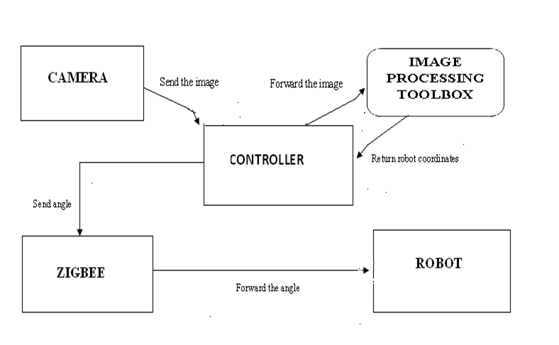

**Fig. 4. DFD Level 1**

1. **IMPLEMENTATION DETAILS:-**

* Initially, the camera captures the image of the whole arena along with the 2 robots placed on it and sends it to the controller (laptop).
* Now, the controller uses image processing concepts like color detection, centroid detection, etc. and determines the position of both the robots.
* Then, the controller calculates the angle of rotation required by each robot such that they face each other after rotation.
* The controller sends the respective angles to each robot through the zigbee assigned for the robots.
* The robots, on reception of its angle, rotate by that angle and if still facing away from the opponent, rotate by further 180 deg.
* The robots then move forward to push the opponent out of the ring.

This is explained in detail in the following flowcharts.

**FLOWCHARTS:- IMAGE PROCESSING**:-

|  |
| --- |
| Input image from camera |

|  |
| --- |
| Detect Blue robot  (circle, rectangle) |

|  |
| --- |
| Detect Red robot  (circle, rectangle) |

|  |
| --- |
| Find centroid of red circle (x1,y1) |

|  |
| --- |
| Find centroid of blue circle(x3,y3) |

|  |  |  |
| --- | --- | --- |
| Find centroid of red rectangle(x2,y2) |  | Find centroid of blue rectangle(x4,y4) |

|  |
| --- |
| Draw line L1 between these coordinates |

|  |
| --- |
| Draw line L1 between these coordinates |

|  |
| --- |
| Find midpoint of these line (L1) |

|  |
| --- |
| Find midpoint of these line(L2) |

|  |
| --- |
| Join these midpoint with another line(L3) |

|  |
| --- |
| Determine the slope for lines  i:e m1 for L1 ,m2 for L2,m3 for L3 |

a

a

|  |
| --- |
| Calculate angles using slopes i:e theta1 between m1 and m3and between m2 and m3 |

False False

Theta1< 0

Theta2< 0

True True

Rotate blue robot by left by angle Theta 2

Rotate red robot by right by angle Theta 1

|  |  |  |
| --- | --- | --- |
| Rotate red robot by right by angle Theta 1 by right |  | Rotate blue robot by right by angle Theta 2 by right |

|  |  |  |
| --- | --- | --- |
| Calculate distance between centroid of  red circle and midpoint of L2(r1) and distance between midpoint of L1 and l2 |  | Calculate distance between centroid of blue circle and midpoint of L1(r3) and distance between midpoint of L1 and l2 |

r3>r2

r1>r2

True False False

True

|  |
| --- |
| Rotate blue robot by  180 |

|  |
| --- |
| Rotate red robot by 180 |

|  |
| --- |
| Move both robots forward |

**WIRELESS COMMUNICATION (ZIGBEE)**:-

Open the COM port for each zigbee

Open the com port for each zigbee

Specify the address of destination and source

Both address matches

False

True

Send the data using fprintf()

to desired ro

Close the COM port

**Fig 5 . Flow Chart**

**BLOCK DIAGRAMS:-**

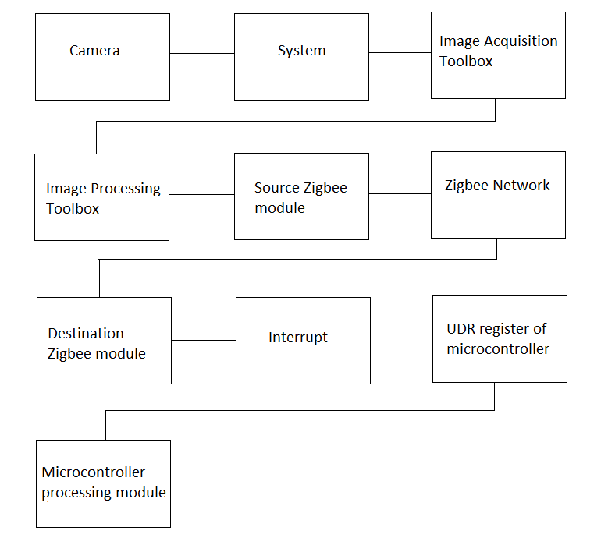

**Fig 6. Block Diagram**

1. **TECHNOLOGIES USED:-**

## **Hardware:**

**1) Spark V**: Spark V robot is based on ATMEGA16A microcontroller. Robot comes with rechargeable 7.2V 600mA NiMH Battery and onboard intelligent battery charger. It has 3 analog white line sensors, 3 analog IR Proximity sensors, 3 directional light intensity sensors, battery voltage sensing, TSOP1738 IR receiver for TV remote control and Position encoders. Robot has support for 3 MaxBotix EZ series ultrasonic range sensors.

It also has support for the servo mounted sensor pod which can be used to make 180 degrees scan for the map making. Robot is powered by 6 cell 7.2V 600mA rechargeable NiMH batteries which gives about one hour battery operation. Robot has built-in Smart Battery Controller which charges the battery in intelligent way and also monitors the battery charge level when robot is in operation.

Robot has 2x16 alphanumeric LCD, Lots of LED indicators for quick debugging, Buzzer etc. Motors are controlled by L293D motor driver. Robot gives top speed of 15cm to 20cm per second depending on the model.

Robot has USB interface for PC connectivity. Robot has onboard socket for XBee wireless module for multi robot and robot to PC communication. You can also control this robot over GUI from NEX Robotics over wired (USB) and wireless (XBee wireless modules) medium. Firmware (.hex file) is loaded on the robot using Bootloader Utility from NEX Robotics.

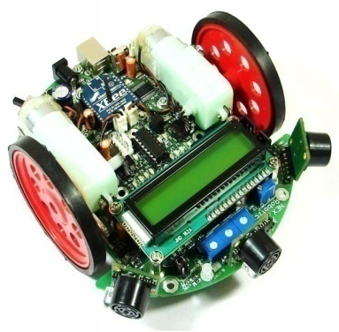

**Fig. 7. SPARK V robot**

**    **



**Fig. 8 SPARK V pin configuration**

**2)****Zigbee module**: ZigBee is the product of the ZigBee Alliance, an organization of manufacturers dedicated to developing a new networking technology for small, ISM-band radios that could welcome even the simplest industrial and home end devices into wireless connectivity.

ZigBee is designed as a low-cost, low-power, low-data rate wireless mesh technology.

The ZigBee specification identifies three kinds of devices that incorporate ZigBee radios, with all three found in a typical ZigBee network .

• a ***coordinator***, which organizes the network and maintains routing tables.

• ***routers***, which can talk to the coordinator, to other routers, and to reduced function end devices.

• ***reduced function end devices***, which can talk to routers and the coordinator, but not to each other.

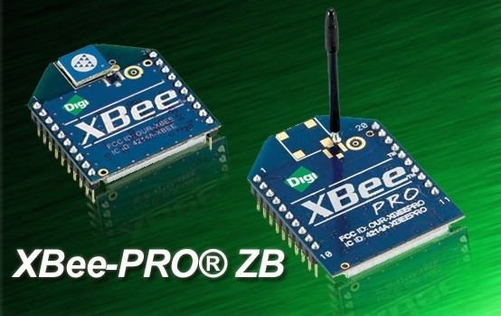

**Fig. 9. Zigbee module**

**3) Camera****:** Camera used will be a digital camera which will placed in a burst mode ,hence it will continuously keep on taking the images.

Camera will mounted exactly perpendicular to the circular arena, so that the image will be taken with less flaws and there will be no flaws in the calculation of the pixel value of the robot.

## **Software:**

**1) MATLAB**: MATLAB is a programming environment for algorithm development, data analysis, visualization, and numerical computation. Using MATLAB, you can solve technical computing problems faster than with traditional programming languages, such as C, C++, and Fortran. MATLAB is used in a wide range of applications, including signal and image processing, communications, control design, test and measurement, financial modeling and analysis, and computational biology. For a million engineers and scientists in industry and academia, MATLAB is the language of technical computing.

**2) AVR Studio**: It is basically used to write the code for the microcontroller of the robot. The language in which it is written is basically C/C++ which are low-level languages.

**3) AVR Bootloader**: It is a software which is basically used for burning the program written in AVR Studio into the microcontroller of the robot.

1. **TEST CASES:-**

|  |  |
| --- | --- |
| **Test Case No.** | **TC 001** |
| **Purpose** | **To test image processing** |
| **Situation** | **Both robots facing each other** |
| **Input** | **Coordinates of robots** |
| **Expected Output** | **Robots should move forward without any rotation** |
| **Test Procedure** | **Angle calculation(i.e. zero)**  **Move forward** |

**Table No. 2**

**Situation:-**

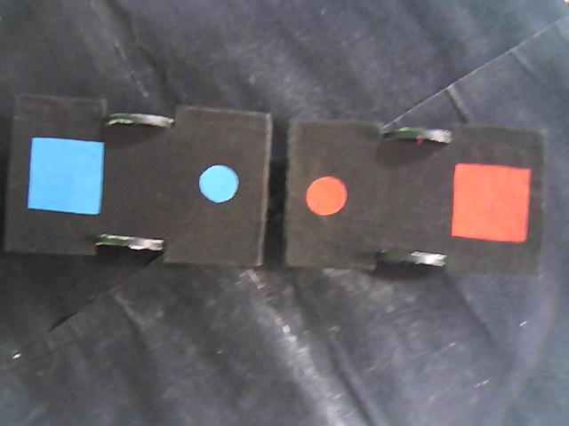

**Fig. 10. Position 1**

**Output:-**

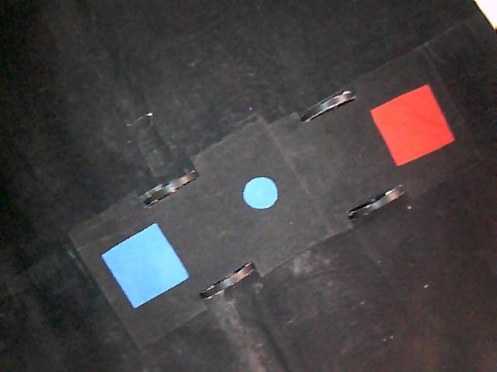

**Fig. 11. Output after rotation of position 1**

|  |  |
| --- | --- |
| **Test Case No.** | **TC 002** |
| **Purpose** | **To test image processing** |
| **Situation** | **Both robots at angle with each other.** |
| **Input** | **Coordinates of robots** |
| **Expected Output** | **Both robots should rotate by appropriate angle such that they face each other, and then move forward** |
| **Test Procedure** | **Angle calculation**  **Rotate by calculated angle**  **Move forward** |

**Table No. 3**

**Situation:-**

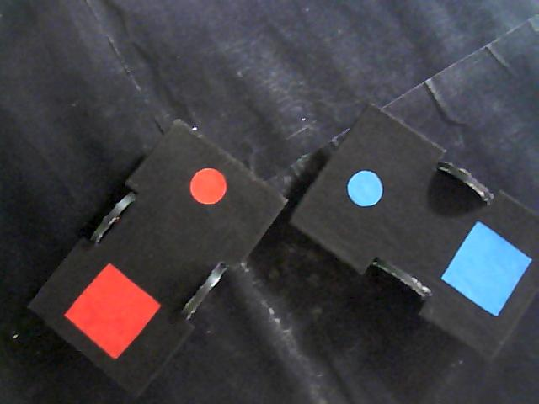

**Fig. 12. Position 2**

**Output:-**



**Fig. 13. Output After Rotation of Position 2**

1. **PROJECT TIMELINE CHART:-**

**Fig. 16. Timeline Chart**

1. **TASK DISTRIBUTION:-**

|  |  |  |  |
| --- | --- | --- | --- |
| Tasks | Umesh Nair | Sreeram Krishnan | Vinod Salunke |
| Setting up the arena |  |  |  |
| Basic movements of robot |  |  |  |
| Image processing |  |  |  |
| Wireless communication using Zigbee |  |  |  |
| Integration |  |  |  |
| Testing |  |  |  |
| Documentation |  |  |  |

**Table No. 5**

1. **CONCLUSION:-**

Thus we can say that using artificial intelligence, the robots can be used in real life for many applications like security, patrolling and entertainment. This project has demonstrated the use of image processing and wireless data transmission using Zigbee and their importance in today's world. Initially, this project was implemented using IR sensors which was quite time-consuming and tedious. By using Image processing in its place, the localization of robots has sped up, making the reactions of the robot much quicker.

1. **FUTURE WORK:-**

This project can be further extended in the following ways:-

* Making use of more than 2 robots that will try and push every other robot out of the ring, or working as a team to push the other team out.
* In the cleaning field, the robot can be made to push only select items out of the specific area, leaving the other items untouched.

**REFERENCES:-**

[1] Tennis Ball Collector Robot By E-Yantra Team: <http://www.e-yantra.org/ci/projects/code/73>

[2] Image Processing using MATLAB: <http://www.mathworks.in/matlabcentral/>

[3] Robert M. Haralick, “Computer and Robot Vision”

[4] Nichu sebe Michel S Lew.,Thomas S Haung: “Computer vision in human-computer interaction”

[5] Hardware and Software manuals of Spark V